|  |  |
| --- | --- |
| Course Name | ITD 2313 – Script Programming |
| Instructor | Put instruction name here |
| Student Name | Put student name here |
| Due date | Put assignment due date here |
| Grade | Put grade earned here |
| Grading Comments | Put instructor comments here |

### Page 65

1. Right in the middle of the page is a for loop example code about being alive, that is the code example for this page.  the Colon and the extra space on the 2nd line are very important.
2. You might noticed a few lines before the example code in Step 1, there is what appears to be another example code.  This is actually a template code for how a for loop is written in python.  It has placeholders for the items that you as a programmer and change.  As such, you do not have to enter this template in as part of the exercise.  There will be other templates as we go through the chapter and the rest of the book.

### Page 66

1. The top third of the page is the home for the first code example of this page.
2. A little below half and the subsection header of Count Controlled Loops is your second on the page of example code blocks.
3. The last of the three example code blocks on the page is in the bottom third of the page. 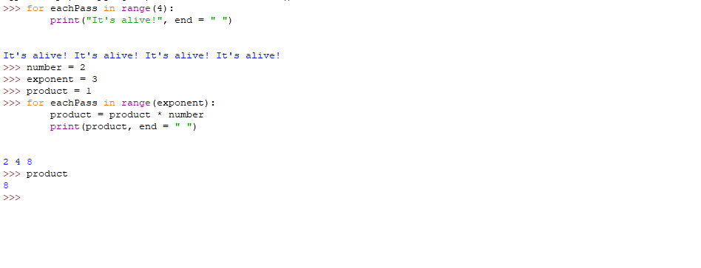

## Count Controlled Loops

### Page 67

1. Near the very top is the first of the three code examples for this page
2. At about the 1/3 way point on the page is the 2nd of the three code example blocks for the page
3. The final code example block on this page is smack in the middle of the page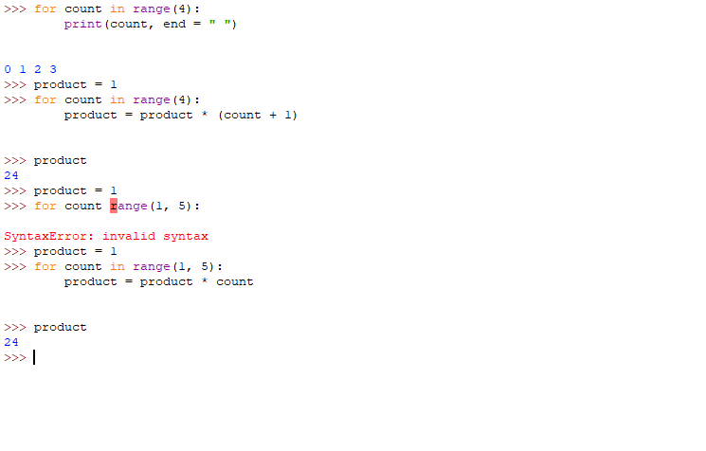

## Loop Errors: off by one error

### Page 68

1. The first of two is just a touch above the 1/2 point on the page.
2. The second of the two comes right after the new subsection started about data sequences.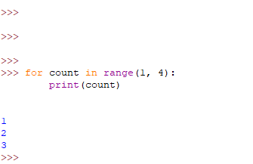

## Traversing the contents of a Data Sequence

### Page 69

1. At the top is the first of 4 code example blocks on this page
2. The 2nd code example block is in the middle of the page, it shows three list examples
3. The third code example block is just below the 2nd.  This one starts with theSum=0 statement.
4. The last one the page is right at the bottom.  Don't worry the code example does not spill onto the next page, it is all on this page.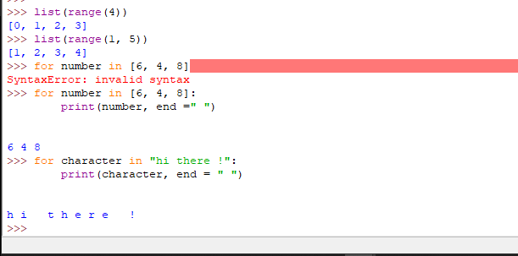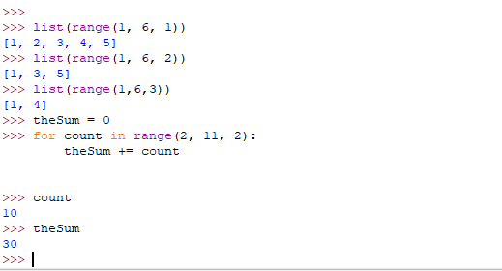

# Formatting Text for Output

### Page71

1. About a 1/3 the way down on the page is your first code example block for the page
2. At the halfway point is the 2nd and final code example block on this page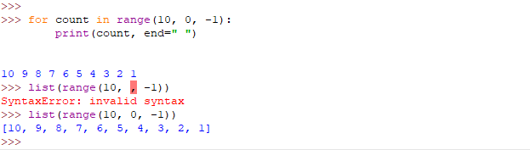

### Page 72

1. The first code example block is near the top of the page
2. The second code example block is at the half way point on the page
3. The final code example block is a just a few lines below the 2nd one.  this one is showing how to show precision on a floating point number of 3.14.

